Lab Report 5

ESE – 3005

EMBEDDED SYSTEMS ARCHITECTURE 2

Submitted to :

Linchan Wang

Submitted by:

Gurvinder Singh(748418)

**Preparing core-image-sato**

* **Executing core-image-sato**

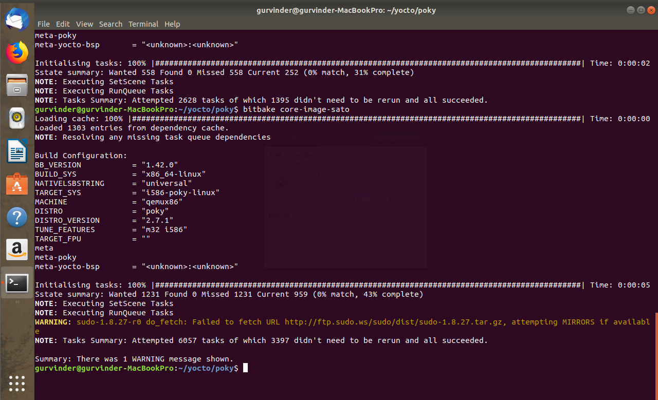

* **Unmount the sdcard for setting up the partition layout.**
* 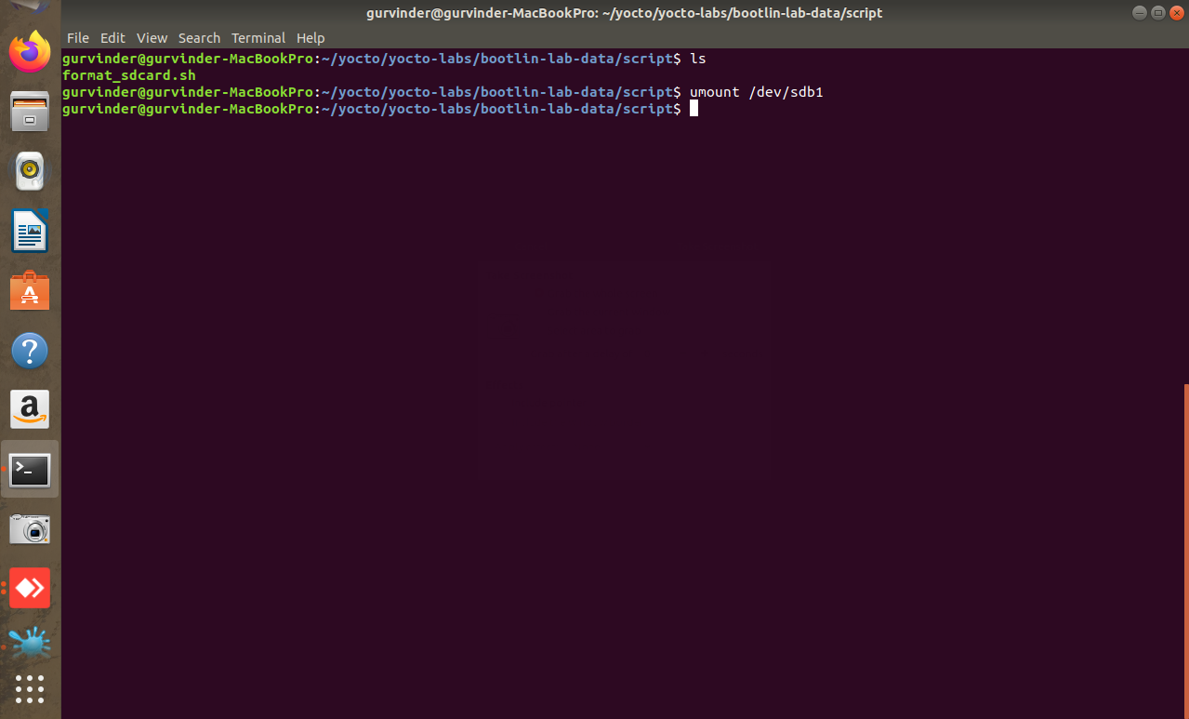**Formatting the sdcard**

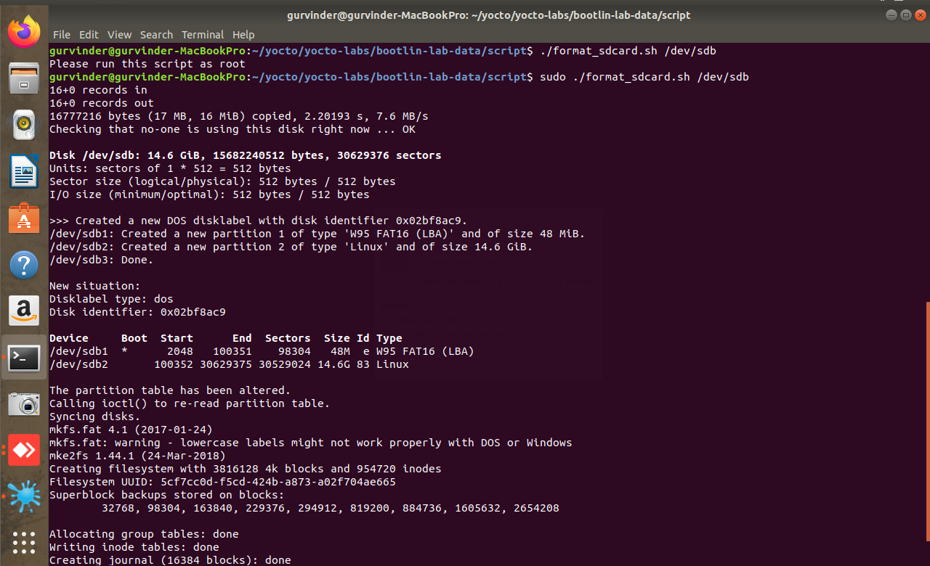

* **Making image bootable.**
* 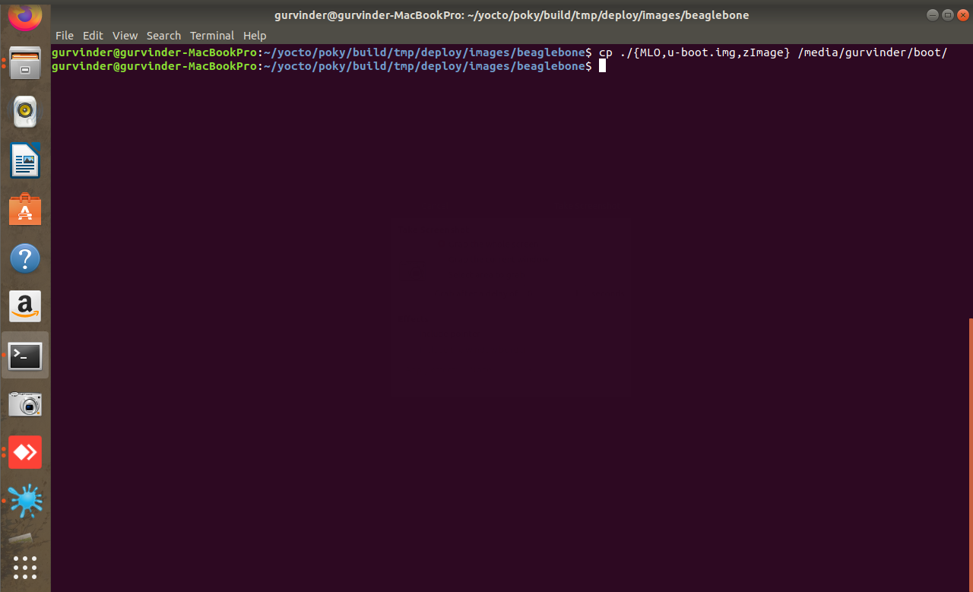**Copy Linux kernel image and device tree in boot partition.**

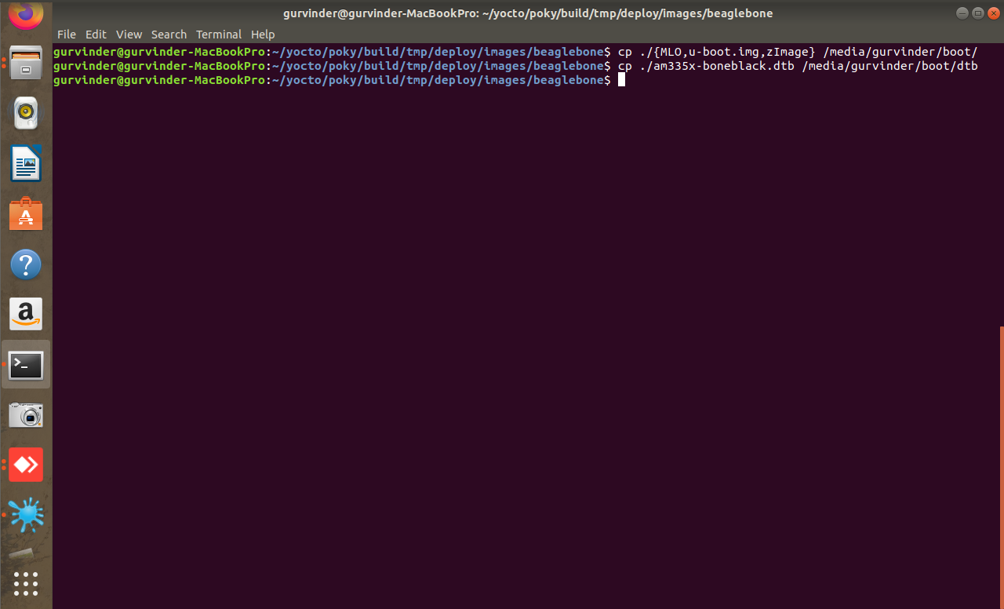

* **Uncompressing generated rootf in second partition.**

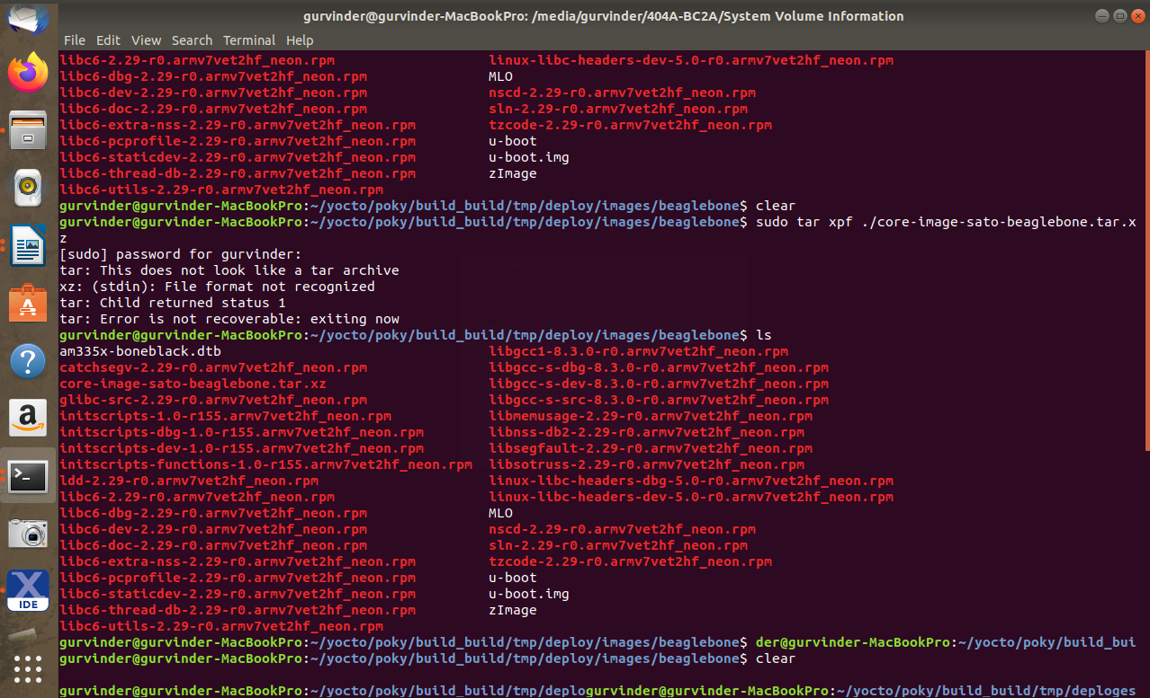

* **Finally, image is ready to display.**

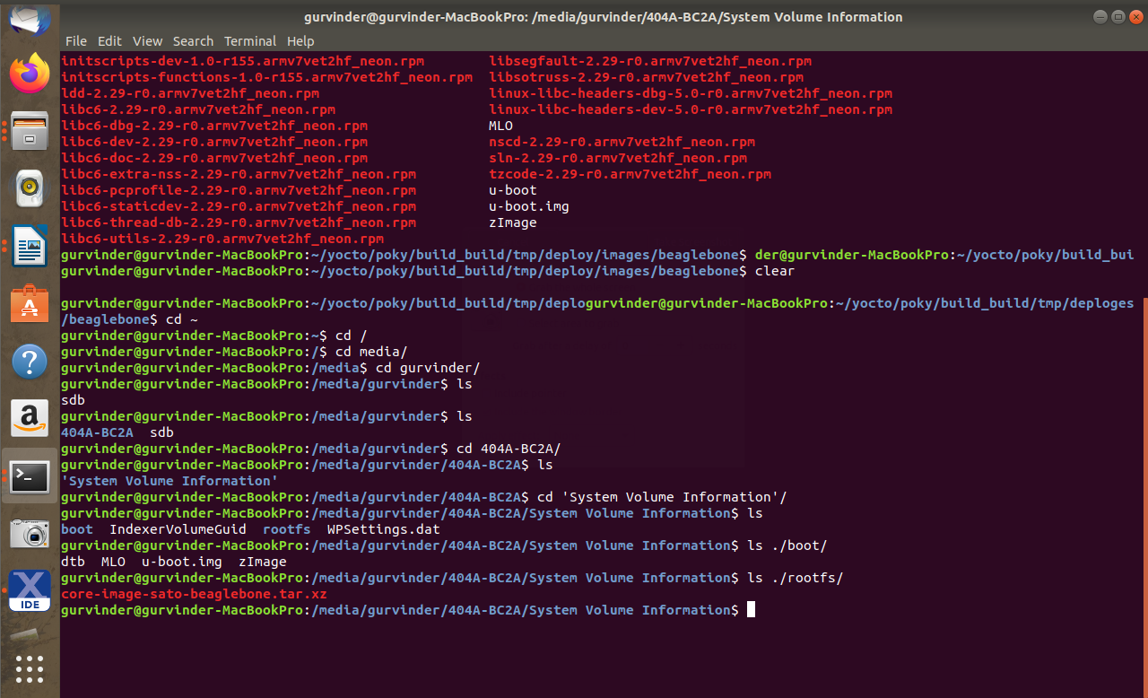

* **Making the Connections**

